**Name: Saif Alam**

**Roll: 61, CSBS**

**Practical 3 ITW**

**Aim:** Write a MATLAB Program to print Amstrong Numbers and Prime Number

**Program:**

for i = 100 : 999

is = num2str(i);

i1 = str2num(is(1));

i2 = str2num(is(2));

i3 = str2num(is(3));

an = i1^3 + i2^3 + i3^3;

if i == an

% We display the pair of equal numbers

disp([i an])

end

end

**Output:**

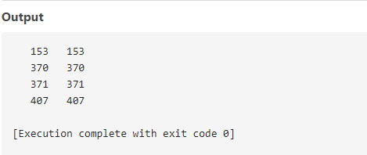

**Program:**

To find prime numbers

n = 50; % Change this value to your desired maximum number

prime_numbers = [];

for num = 2:n

is_prime = true;

for div = 2:sqrt(num)

if rem(num, div) == 0

is_prime = false;

break;

end

end

if is_prime

prime_numbers = [prime_numbers, num];

end

end

disp(prime_numbers);

**Output:**

